Development projects
Developer Manual

Table of Contents
Introduction 2
Prerequisites 2
Initial Tests 3
PI Simulator 4
TD Engine Custom Data Reference 6
VS Projects 6
How to install/update the TDEngine Custom Data Reference? 6
Troubleshooting CDR certificate issues 12
Future Work 14
TD PI Connector 15
VS Projects 15
Compiling for Cloud only 15
Future Work 15

Introduction
The GitHub repository td-pi-connector has four projects. Each project is a section of this manual.

Prerequisites
All C# projects require the following prerequisites to compile:
- .NET Framework 4.7.2+
- Visual Studio 2019+
- PI AF Client 2018+
- TD Engine 3.0.1.5+ (cloud or on-premise)

Initial Tests

This was the first project developed to start testing how the integration could be done.
Here is the workflow of the application:
- Connects to PI Data Archive and PI AF Server
- Connects to TDEngine
- Migrate PI Points
  - The list of PI Points is below:
    - "cdt158"
    - "sinusoid"
    - "sinusoidu"
    - "TEST_DIGITAL"
    - "TEST_FLOAT16"
    - "TEST_FLOAT32"
    - "TEST_FLOAT64"
    - "TEST_INT16"
    - "TEST_INT32"
    - "TEST_STRING"
    - "TEST_TIMESTAMP"
  - For each PI Point, a TDEngine database, supertable and table are created with the correct column type.
  - Then the values are migrated with the following steps:
    - Create batches, each one with 5000 PI values
    - For each batch, a SQL Command is generated to insert those values on TDEngine, using the Parallel.ForEach method
    - Finally, 30 tasks run in parallel at the same time, each one makes an HTTP request against TDEngine with the Insert statement.

- Migrate AF
  - This will find all AF Element instance of an AF Template Element
  - For each AF Element, a TDEngine table is created with many attributes as columns
  - Data is migrated using a multi-threaded approach very similar as it was done when migrating the PI Points

I think the most interesting value of this project is that it is the only project that uses a multi-threaded approach to retrieve data from PI and send it to TDEngine.

PI Simulator

The PI Simulator is a Windows Service that creates an AF database with a full AF tree of elements and attribute and keeps sending real-time data to it.

On the PISimulator.Service.config file edit the following parameters:

<appSettings>
<add key="UpdateInterval" value="5000" />
<add key="PISystemName" value="MARC-PI2018" />
<add key="PIServerName" value="MARC-PI2018" />
</appSettings>
</configuration>
Then edit the AFSettings.json file to set how each attribute value should behave. Here is an example:

{
"AFDatabase": "Meters",
"PIPointPrefix": "Meters_",
"ElementTemplate": {
"Name": "MeterTemplate",
"AttributeTemplates": [
{
"Name": "Current",
"Type": "double",
"UOM": "A"
},
{
"Name": "Power",
"Type": "double",
"UOM": "W"
},
{
"Name": "Voltage",
"Type": "double",
"UOM": "V"
}
]
},
"AFTree": {
"California": {
"San Francisco": {
"Meters": [
{
"Id": 0,
"Type": "SinusoidWave",
"TimePeriod": 120,
"Current": {
"LowerLimit": 4.0,
"HigherLimit": 28.0,
"RandomNoise": 0.0,
"OffsetPhase": 0.0
},
"Voltage": {
"LowerLimit": 114.0,
"HigherLimit": 126.0,
"RandomNoise": 0.0,
"OffsetPhase": 0.0
}
},
{

Quick comments about each parameter:
- AFDatabase: name of the AF database
- PIPointPrefix: prefix that each PI Point needs to start
- ElementTemplate:
  - Name: name of the Element Template that will be created
  - Attribute Template: list of attribute templates including name, type and UOM.
- AFTree
  - Element Root: In the example California, San Diego and Los Angeles are the element roots
  - Each element root has a Meters element
  - Each Meters has many child meter with the following properties:
    - Id: Id of the meter
    - Types available: SinusoidWave, TriangleWave and SquareWave
    - Time period: Seconds of each cycle
    - Then each meter could have several attributes with the following attributes:
      - LowerLimit: minimum value of the attribute.
      - HigherLimit: maximum value of the attribute.
      - RandomNoise: artificial noise added to the values
      - OffsetPhase: artificial offset phase added to the values (from 0 to 360).

TD Engine Custom Data Reference

VS Projects
The TDEngineDR VS solution has 3 projects:
- CopyPdb When the custom data reference library is compiled, the assembly version is increased. Let’s suppose the assembly version is 2.0.1, then the program reads the new assembly version and copy the PDB file to the folder C:\ProgramData\OSIsoft\AF\PlugIns\2.0.1. Copying the PDB file allow the Visual Studio to live debug the TDEngineDR using Visual Studio by attaching to the AFExplorer.exe process.
- ManualTests After registering the DLL, we compare the results between an AF Attribute with PI Point Data Reference and another AF Attribute with TDEngine Data Reference. This allow us to see if the overloaded methods are working as expected.
- TDEngineDR This is the project with the TDEngine Custom Data Reference.

How to install/update the TDEngine Custom Data Reference?

- Compile the TDEngineDR Visual Studio project.
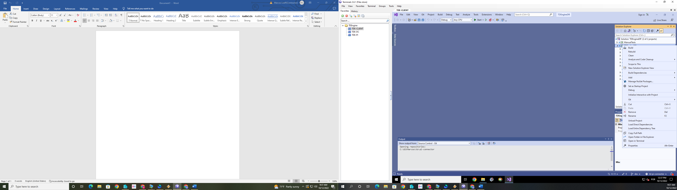

- The compiled versions for Debug and Release are going to be copied to the dist folder.

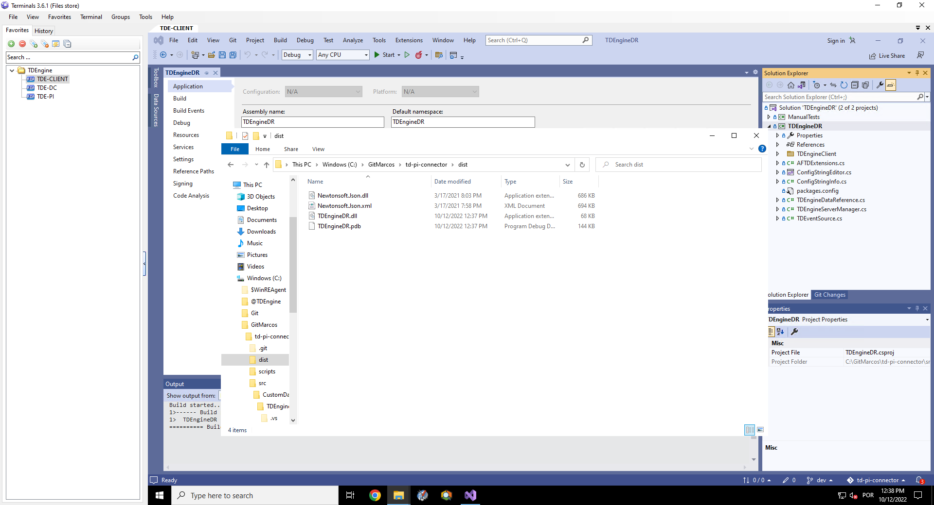

- Check the TDEngineDR.dll file properties to see if the version was incremented.

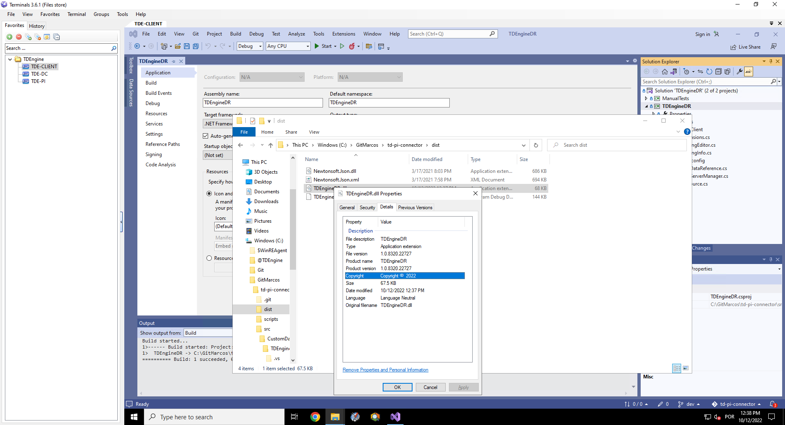

- Go to the \td-pi-connector\scripts folder and run the file process.bat, whose workflow is below:
  - Close AF Explorer
  - Unregister TDEngineDR.dll
  - Sign the DLL
  - Register the new TDEngineDR.dll
  - Copy TDEngineDR.pdb to the subfolder of C:\ProgramData\OSIsoft\AF\PlugIns

- If there are no errors, the procedure has finished.
- Nevertheless, it is possible that the certificate won’t be found or wasn’t created yet. In this case we need to create a new certificate.
C:\>"C:\Program Files (x86)\Microsoft SDKs\ClickOnce\SignTool\signtool.exe" sign /debug /a /t http://timestamp.digicert.com /v "TDEngineDR.dll"

The following certificates were considered:
After EKU filter, 0 certs were left.
After expiry filter, 0 certs were left.
After Private Key filter, 0 certs were left.
SignTool Error: No certificates were found that met all the given criteria.

- In case the certificate is not found, run the sign-af-cdr.ps1 script with admin privileges.
- Under the \td-pi-connector\scripts folder, run the file process.bat again.

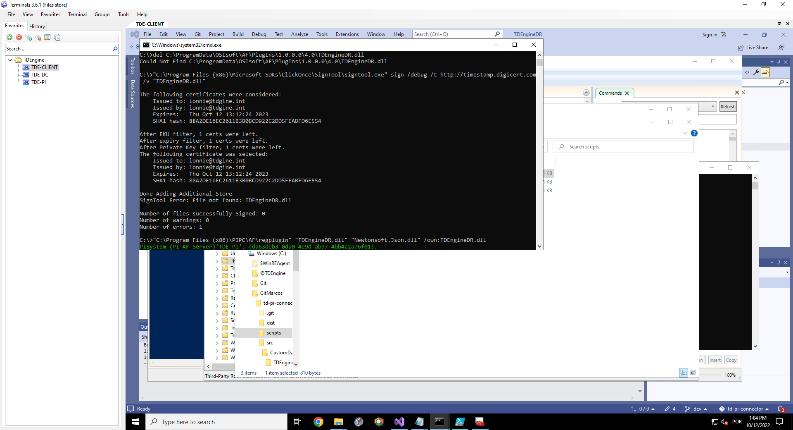
This time it should work. If you’ve executed the sign-af-cdr.ps1, a few more steps are required:
- Export the new certificate created to C:\Working Certificate\working_cert.crt.
- Import the certificate to the Trusted Root Certificate Authorities folders of the User and Computer certificate stores of TDE-PI and TDE-CLIENT machines.

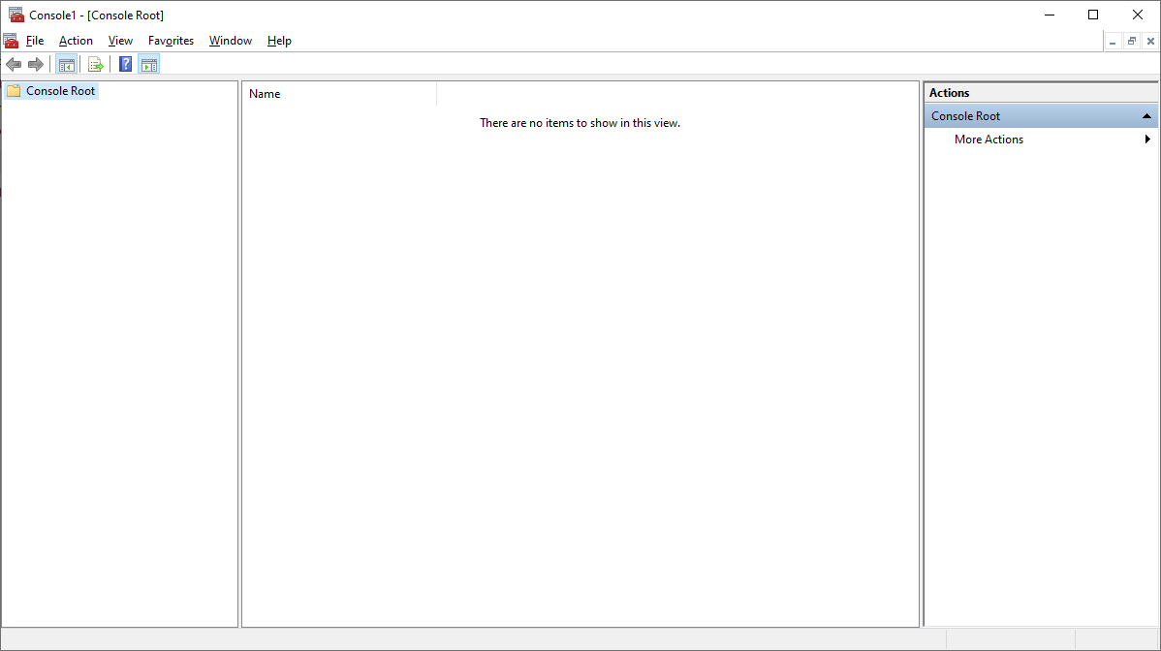

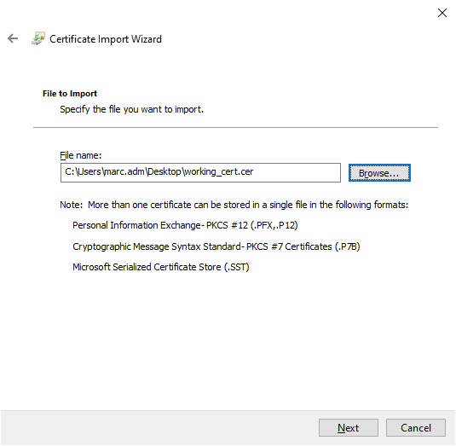

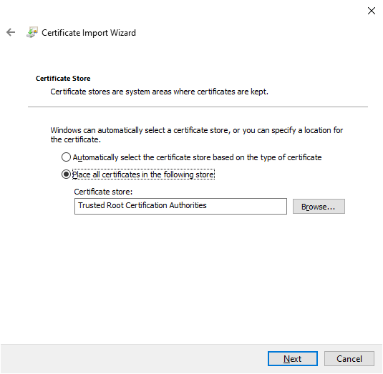
- Finally, make sure PI System Explorer is loading the plugin correctly.

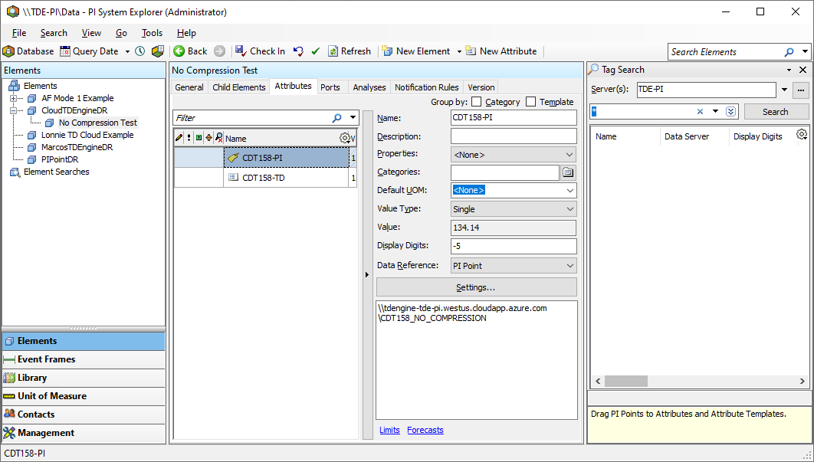

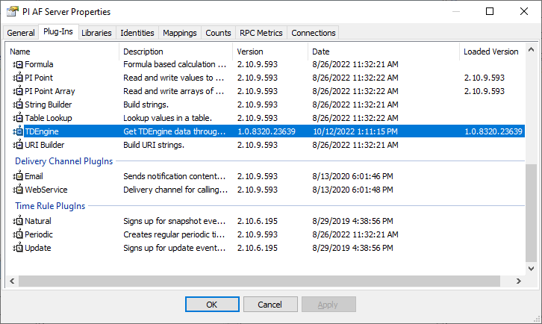

Troubleshooting CDR certificate issues

Go to C:\ProgramData\OSIsoft\AF\PlugIns\1.0.8322.23488\4.0 and right-click on the TDEngineDR.dll and select properties. Go to “Digital Signatures” tab, select the certificate and click on “Details”.

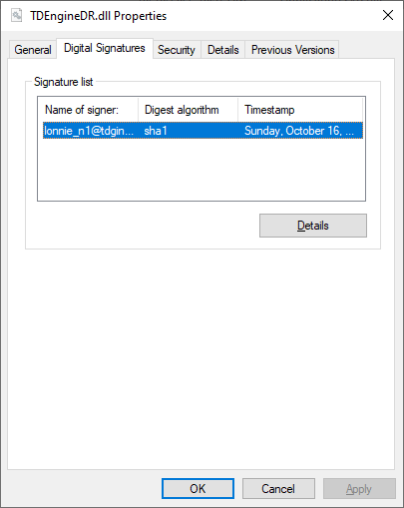

As you can see on the screenshot below, it said that “The digital signature is OK”.

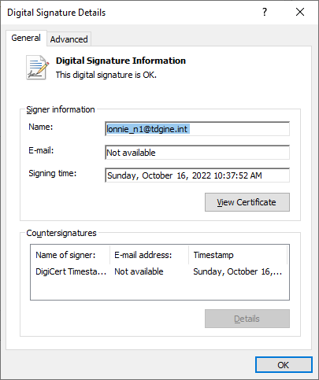

In case this is not true, you can click on “View Certificate” and then “Install Certificate”. This will probably solve the issue.

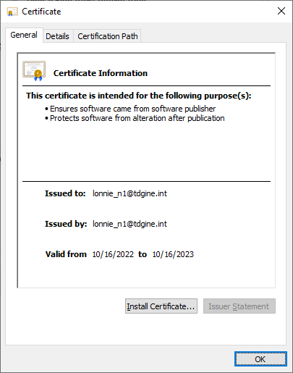

Future Work
Below are some suggestions to improve the custom data reference:
- Implement Data Pipes with TDEngine subscriptions.
- For PI Analysis, make the TDEngineDR compatible with event-triggered scheduling with the AF Data Pipe implemented. Currently, only the periodic scheduling is compatible.
- Configure TDEngine database within the AF Configuration database. Now it is hardcoded with “pi”.
- Use bulk calls when retrieving values for multiple TDEngine tables or columns (if appropriate).
- For AF Element mode, replace naming convention for the columns using {attribute_name}_ val to just the attribute name.
- Add logging for troubleshooting.
- Improve performance.

TD PI Connector

VS Projects
The TDPIConnector VS solution has 8 projects:
- TDBackfill Console application for backfilling past data
- TDPIConnector.Core Core logic of TD PI Connector solution.
- TDPIConnector.CsvPointBuilder Windows Form application with PI AF SDK to edit Points.csv file.
- TDPIConnector.PI Class library to communicate with PI AF and PI Data Archive.
- TDPIConnector.Service Windows Service that calls classes from the TDPIConnector.Core assembly.
- TDPIConnector.TDEngine Class library to communicate with TDEngine.
- TDPIConnector.Setup Setup wizard to install the product.
- TDPIConnector.Web Angular application for the monitoring && troubleshooting web portal.

Compiling for Cloud only
Open the TDEngineClient.cs file.
The first line if you want to compile for cloud only should be:
#define CLOUD_LICENSE_ONLY
The first line if you want to compile for cloud and on-premise just modify the key above. It could be:
#define CLOUD_LICENSE
Save and compile your VS solution.

Future Work
Below are some suggestions to improve the TD PI Connector:
- Writing data using multi-threaded approach.
- Perform stress tests with a big PI System (1 million points).
- For AF Element mode, replace naming convention for the columns using {attribute_name}_ val to just the attribute name.
- Improve performance.
- Automatically detect changes to config files (currently we need to restart the service)
- Solves possible conflicts in TDEngine table names between Point and Element modes (if they both have the same name).
- Add unit and integration tests.
- Improve availability/fault-tolerance
- Convert Int16, Int32 and Int64 to SMALLINT, INT and BIGINT.
- Convert Float32 to TDEngine FLOAT.
- Make it compatible with multiple AF Servers, AF Databases and PI Data Archives.

